A000-EUR-Crete-Minoan cup-**Agyios Onouphrios, Lebena-EM I-**-2200-1600 BCE

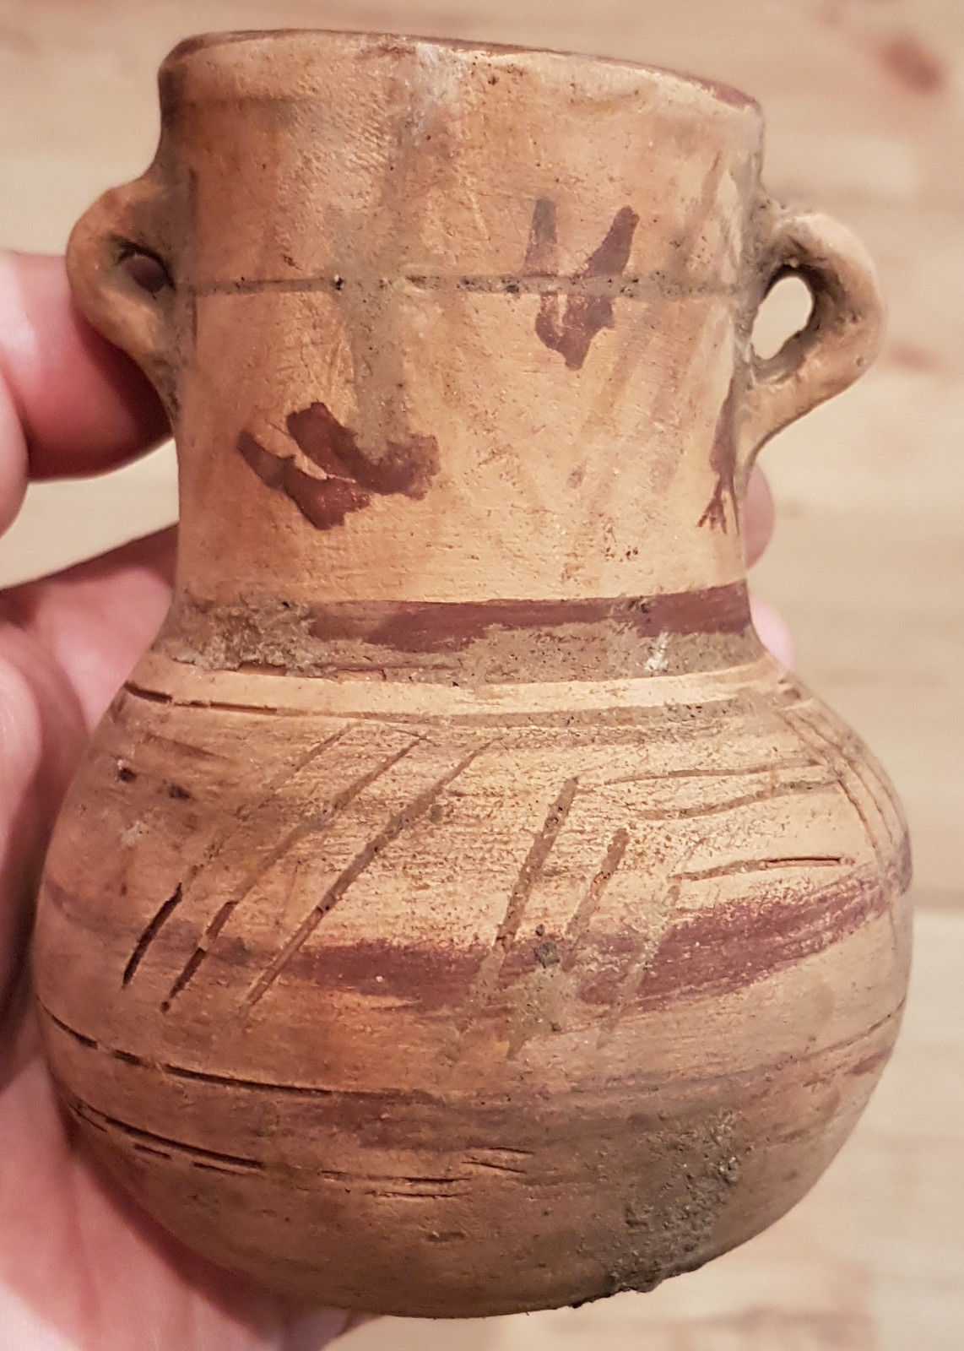 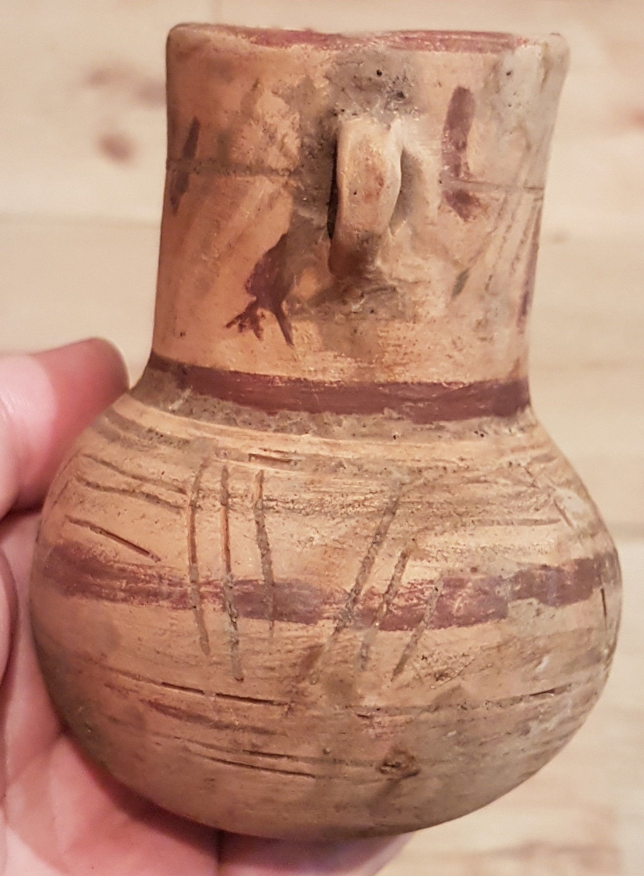

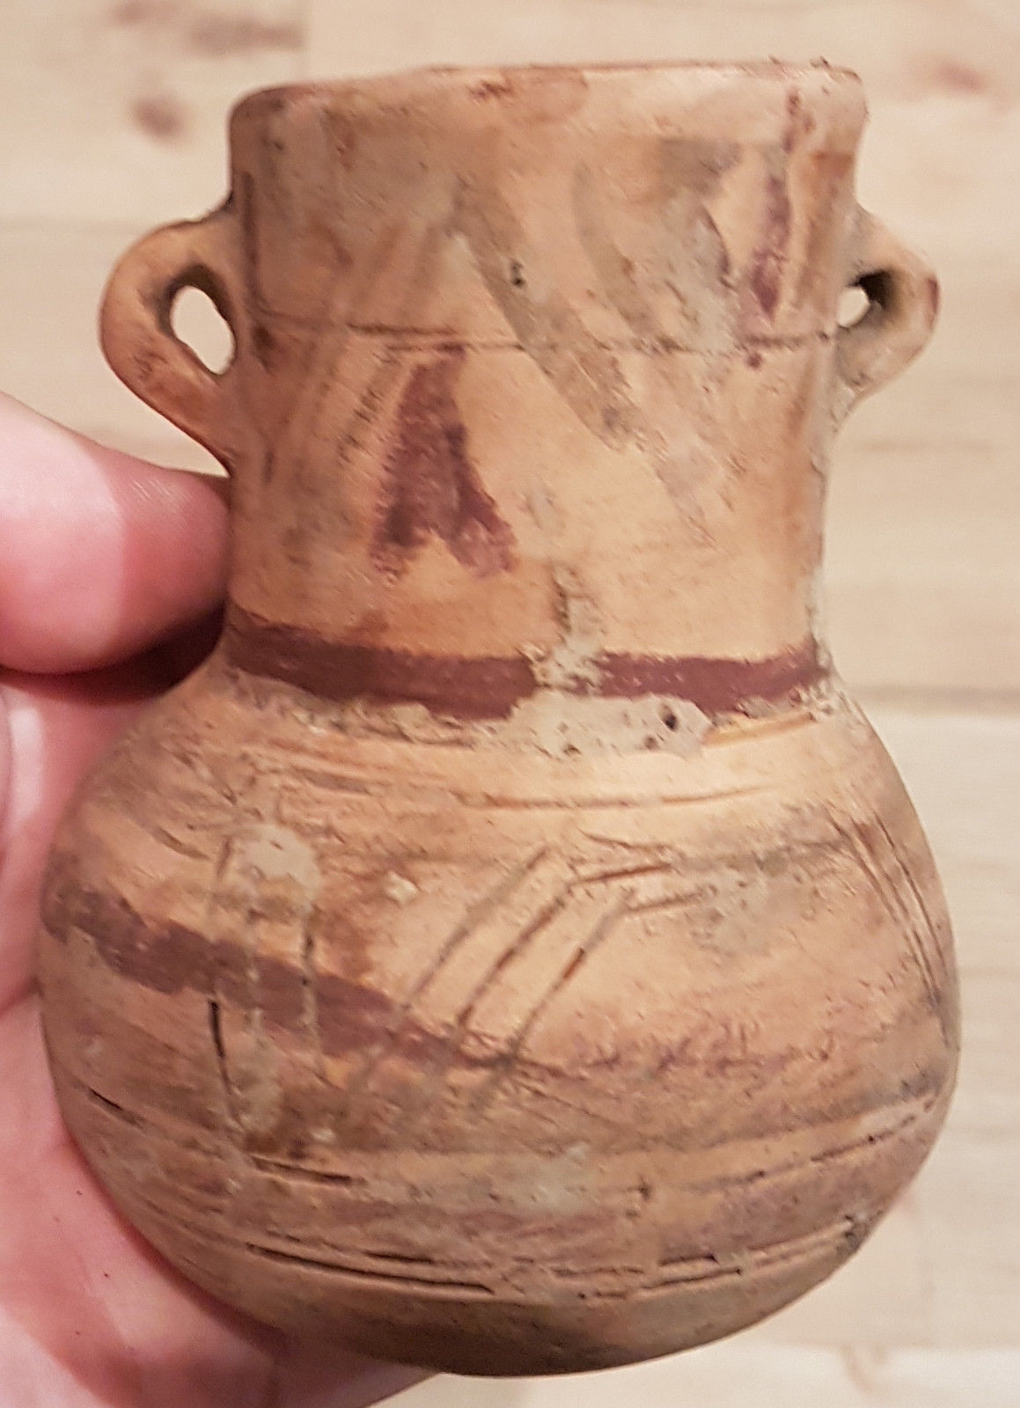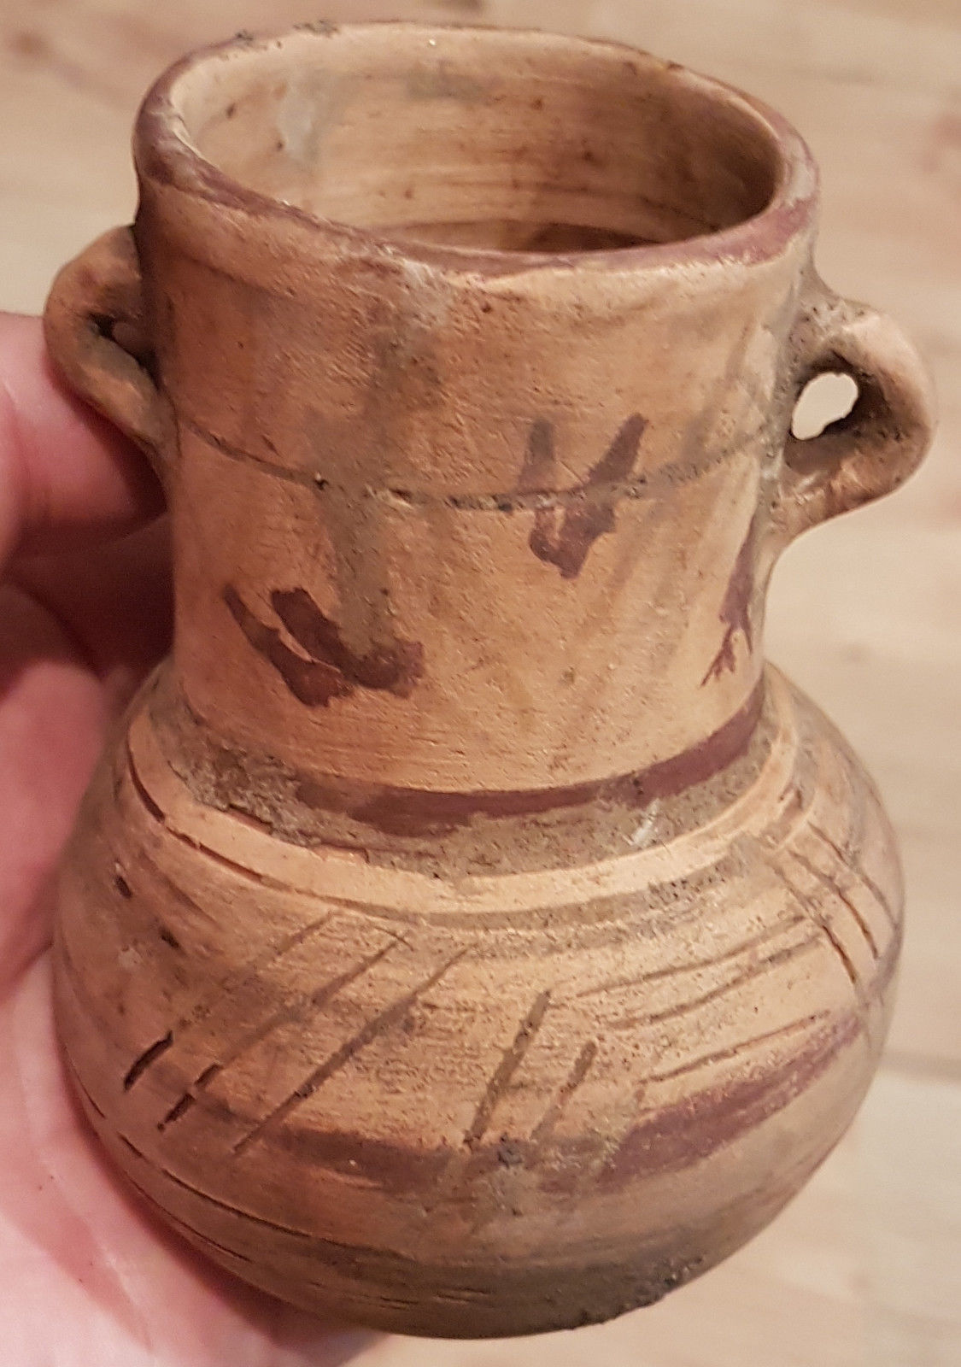 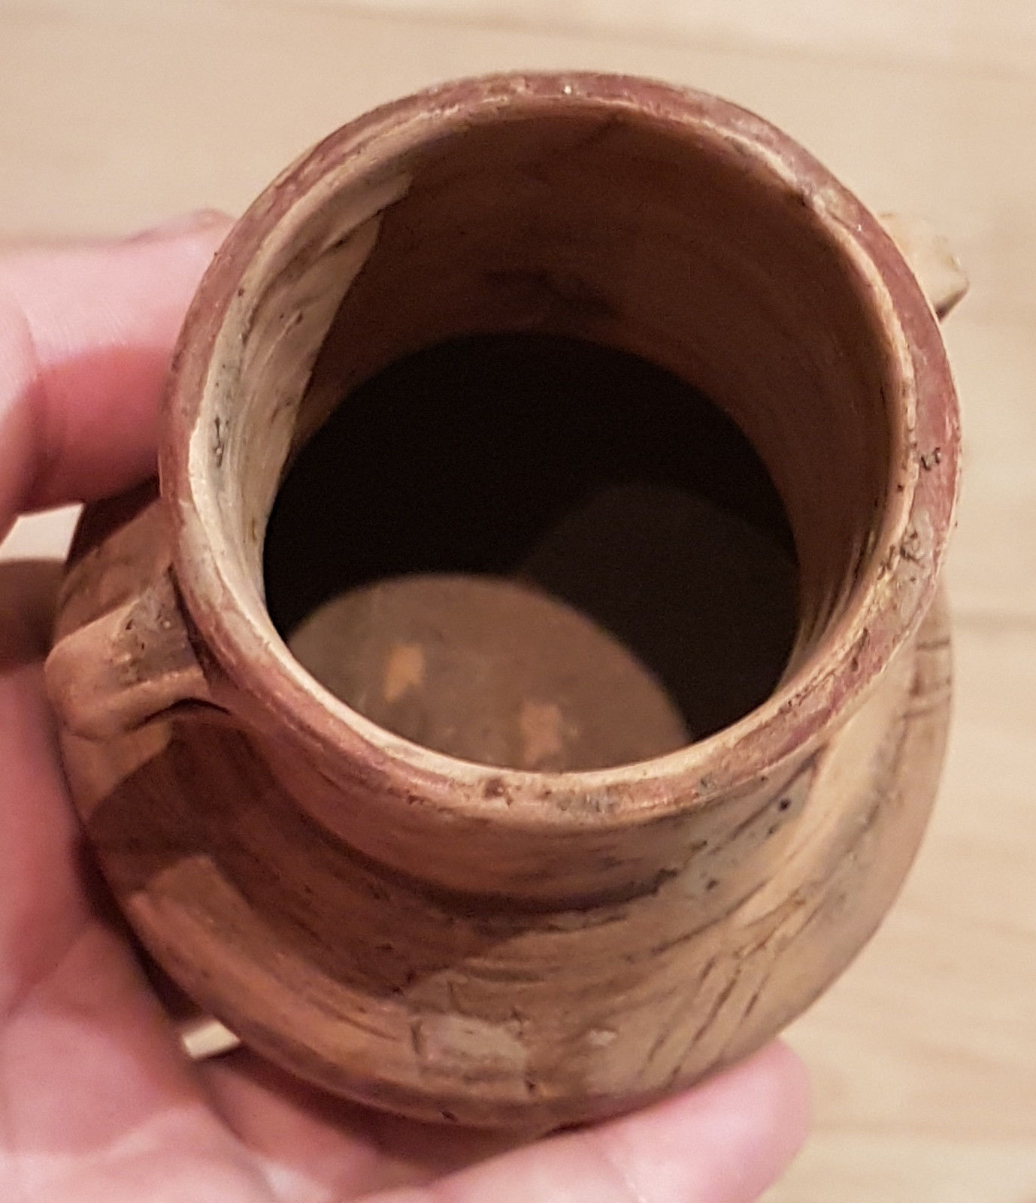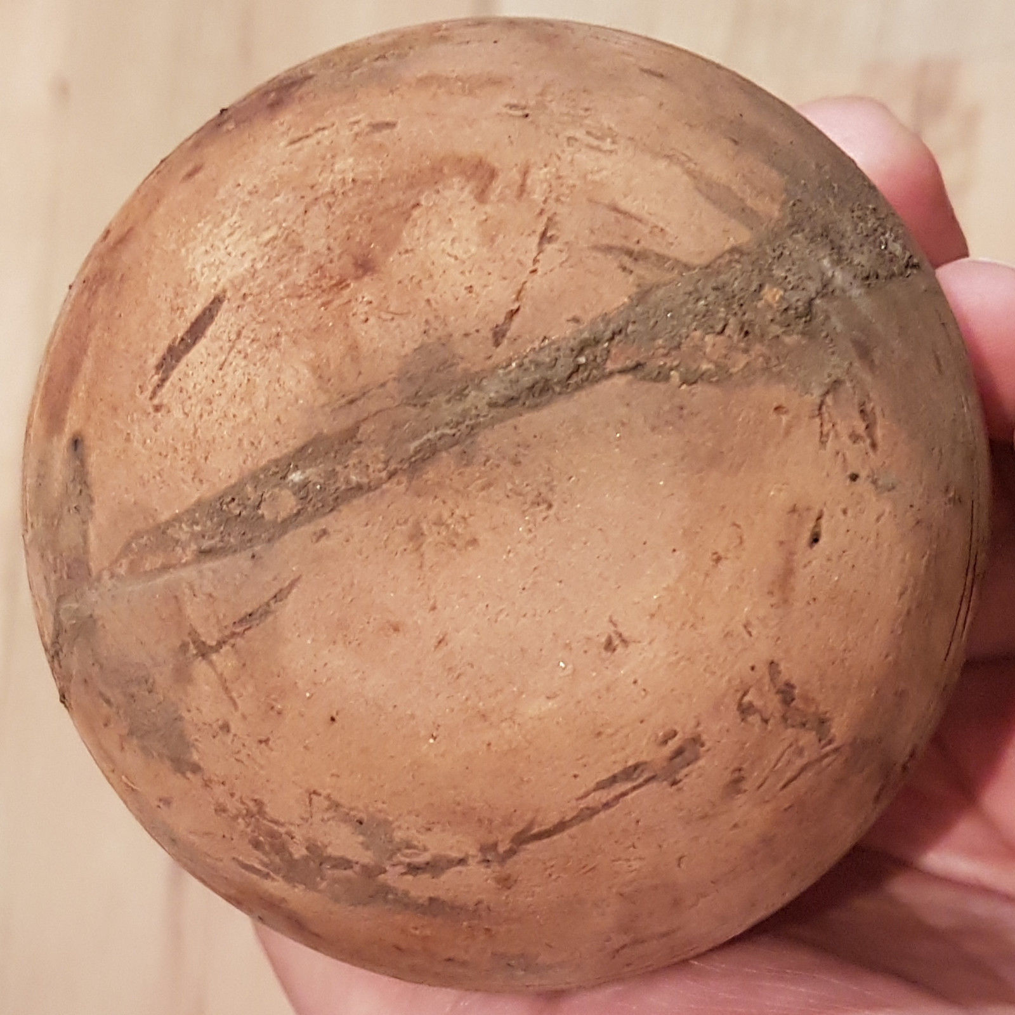

EUR-Crete-Minoan cup-2200-1600 BCE

Case no.: 4

Accession Number:

Formal Label: EUR-Crete-Minoan cup-2200-1600 BCE

**Display Description:**

Painted parallel-line decors of **Ayios Onouphrios I Ware** were drawn with an iron-red clay slip that would fire red under oxidizing conditions in a clean kiln but under the reducing conditions of a smoky fire would turn darker, without much control over color, which could range from red to brown. A dark-on-light painted pattern was then applied. ([Examples 1](https://web.archive.org/web/20040628062134/http:/ccwf.cc.utexas.edu/~bruceh/cc307/minoan/images/2d.jpg), [Examples 2](http://www.fhw.gr/chronos/02/crete/en/gallery/pm_pot10.html).) From this beginning, Minoan potters already concentrated on the linear forms of designs, perfecting coherent designs and voids that would ideally suit the shape of the ware. Shapes were jugs, two-handled cups and bowls. The ware came from north and south central Crete, as did **Lebena Ware** of the same general types but decorated by painting white patterns over a solid red painted background ([Example](http://www.fhw.gr/chronos/02/crete/en/gallery/pm_pot9.html)). The latter came from EM I tombs.

## Traditional chronology

The traditional chronology for dating [Minoan civilization](https://ipfs.io/ipfs/QmXoypizjW3WknFiJnKLwHCnL72vedxjQkDDP1mXWo6uco/wiki/Minoan_civilization.html) was developed by Sir [Arthur Evans](https://ipfs.io/ipfs/QmXoypizjW3WknFiJnKLwHCnL72vedxjQkDDP1mXWo6uco/wiki/Arthur_Evans.html) in the early years of the 20th century AD. His terminology and the one proposed by [Nikolaos Platon](https://ipfs.io/ipfs/QmXoypizjW3WknFiJnKLwHCnL72vedxjQkDDP1mXWo6uco/wiki/Nikolaos_Platon.html) are still generally in use and appear in this article. For more details, see the [Minoan chronology](https://ipfs.io/ipfs/QmXoypizjW3WknFiJnKLwHCnL72vedxjQkDDP1mXWo6uco/wiki/Minoan_chronology.html).

Evans classified fine pottery by the changes in its forms and styles of decoration. Platon concentrated on the episodic history of the Palace of [Knossos](https://ipfs.io/ipfs/QmXoypizjW3WknFiJnKLwHCnL72vedxjQkDDP1mXWo6uco/wiki/Knossos.html). A new method, fabric analysis, involves geologic analysis of coarse and mainly undecorated sherds as though they were rocks. The resulting classifications are based on composition of the sherds.[[1]](https://ipfs.io/ipfs/QmXoypizjW3WknFiJnKLwHCnL72vedxjQkDDP1mXWo6uco/wiki/Minoan_pottery.html" \l "cite_note-1)

## Early Minoan

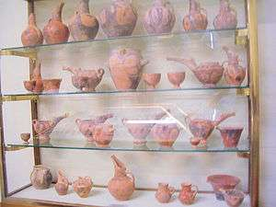

Shelves of Early Minoan pottery, mainly Vasiliki Ware, [Heracleion Archaeological Museum](https://ipfs.io/ipfs/QmXoypizjW3WknFiJnKLwHCnL72vedxjQkDDP1mXWo6uco/wiki/Heracleion_Archaeological_Museum.html) at [Iraklio](https://ipfs.io/ipfs/QmXoypizjW3WknFiJnKLwHCnL72vedxjQkDDP1mXWo6uco/wiki/Iraklio.html).

A brief introduction to the topic of Early Minoan pottery is stated below. It concentrates on some better-known styles but should not be regarded as comprehensive. A variety of [forms](http://www.fhw.gr/chronos/02/crete/en/gallery/ceram17.html) is known. The period is generally characterized by a large number of local wares with frequent Cycladic parallels or imports, suggesting a population of checkerboard ethnicity deriving from various locations in the eastern Aegean or even wider. The evidence is certainly open to interpretation, and none is decisive.

The period is generally characterized by a large number of local wares with frequent Cycladic parallels or imports, suggesting a population of checkerboard ethnicity deriving from various locations in the eastern Aegean or even wider. The evidence is certainly open to interpretation, and none is decisive.

**FN, EM I**

Early Minoan pottery, to some extent, continued, and possibly evolved from, the Final Neolithic[[2]](https://ipfs.io/ipfs/QmXoypizjW3WknFiJnKLwHCnL72vedxjQkDDP1mXWo6uco/wiki/Minoan_pottery.html" \l "cite_note-2) (FN) without a severe break. Many suggest that Minoan civilization evolved *in situ* and was not imported from the East. Its other main feature is its variety from site to site, which is suggestive of localism of Early Minoan social traditions.

Studies of the relationship between EM I and FN have been conducted mainly in East Crete.[[3]](https://ipfs.io/ipfs/QmXoypizjW3WknFiJnKLwHCnL72vedxjQkDDP1mXWo6uco/wiki/Minoan_pottery.html" \l "cite_note-3) There the Final Neolithic has affinities to the Cyclades, while both FN and EM I settlements are contemporaneous, with EM I gradually replacing FN. Of the three possibilities, no immigration, total replacement of natives by immigrants, immigrants settling among natives, Hutchinson[[4]](https://ipfs.io/ipfs/QmXoypizjW3WknFiJnKLwHCnL72vedxjQkDDP1mXWo6uco/wiki/Minoan_pottery.html" \l "cite_note-4) takes a compromise view:

"The Neolithic Period in Crete did not end in a catastrophe; its culture developed into that of the Bronze Age under pressure from infiltration of relatively small bands of immigrants from the south and east, where copper and bronze had long been in use."

**Agyios Onouphrios, Lebena**

Painted parallel-line decors of **Ayios Onouphrios I Ware** were drawn with an iron-red clay slip that would fire red under oxidizing conditions in a clean kiln but under the reducing conditions of a smoky fire would turn darker, without much control over color, which could range from red to brown. A dark-on-light painted pattern was then applied. ([Examples 1](https://web.archive.org/web/20040628062134/http:/ccwf.cc.utexas.edu/~bruceh/cc307/minoan/images/2d.jpg), [Examples 2](http://www.fhw.gr/chronos/02/crete/en/gallery/pm_pot10.html).) From this beginning, Minoan potters already concentrated on the linear forms of designs, perfecting coherent designs and voids that would ideally suit the shape of the ware. Shapes were jugs, two-handled cups and bowls. The ware came from north and south central Crete, as did **Lebena Ware** of the same general types but decorated by painting white patterns over a solid red painted background ([Example](http://www.fhw.gr/chronos/02/crete/en/gallery/pm_pot9.html)). The latter came from EM I tombs.

**LC Classification:**

Date or Time Horizon: Minoan cup  Vasiliki Ware,  c 2200-1600 BCE

Geographical Area: Lebena, Crete

**Map:**

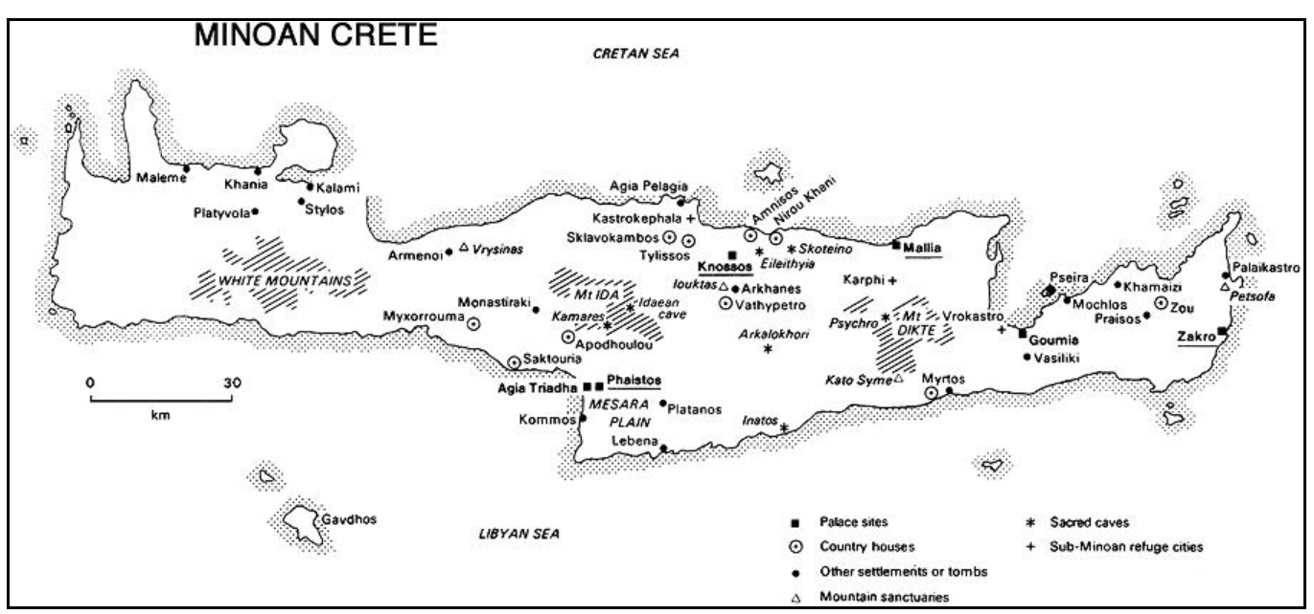

**GPS coordinates:**

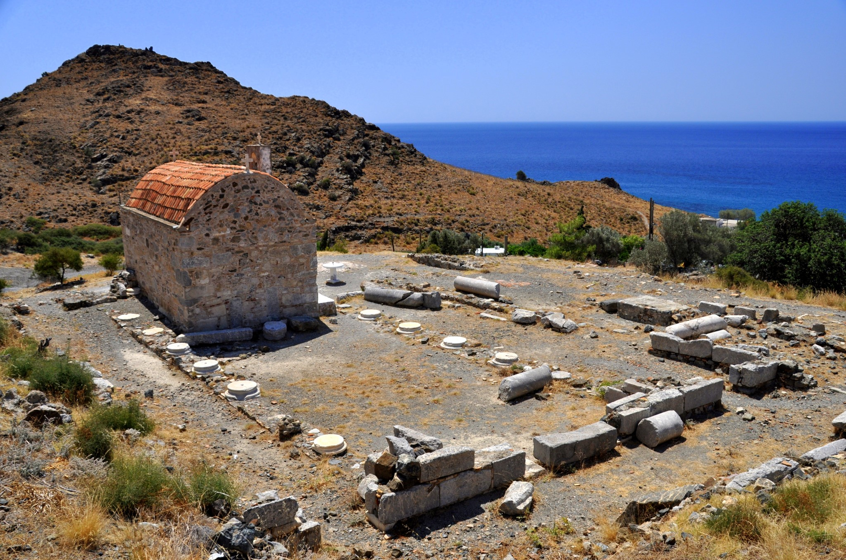

Lebena Archaeological Site, Crete, with the imposition of a Christian Chapel over the shrine of the most sacred area, a typical way of attempting to desecrate an ancient pre-Christian holy site, which, of course, it did not.

Cultural Affiliation:

Media: Dimensions:

Weight:

Condition:

Provenance:

**Discussion:**

**References:**